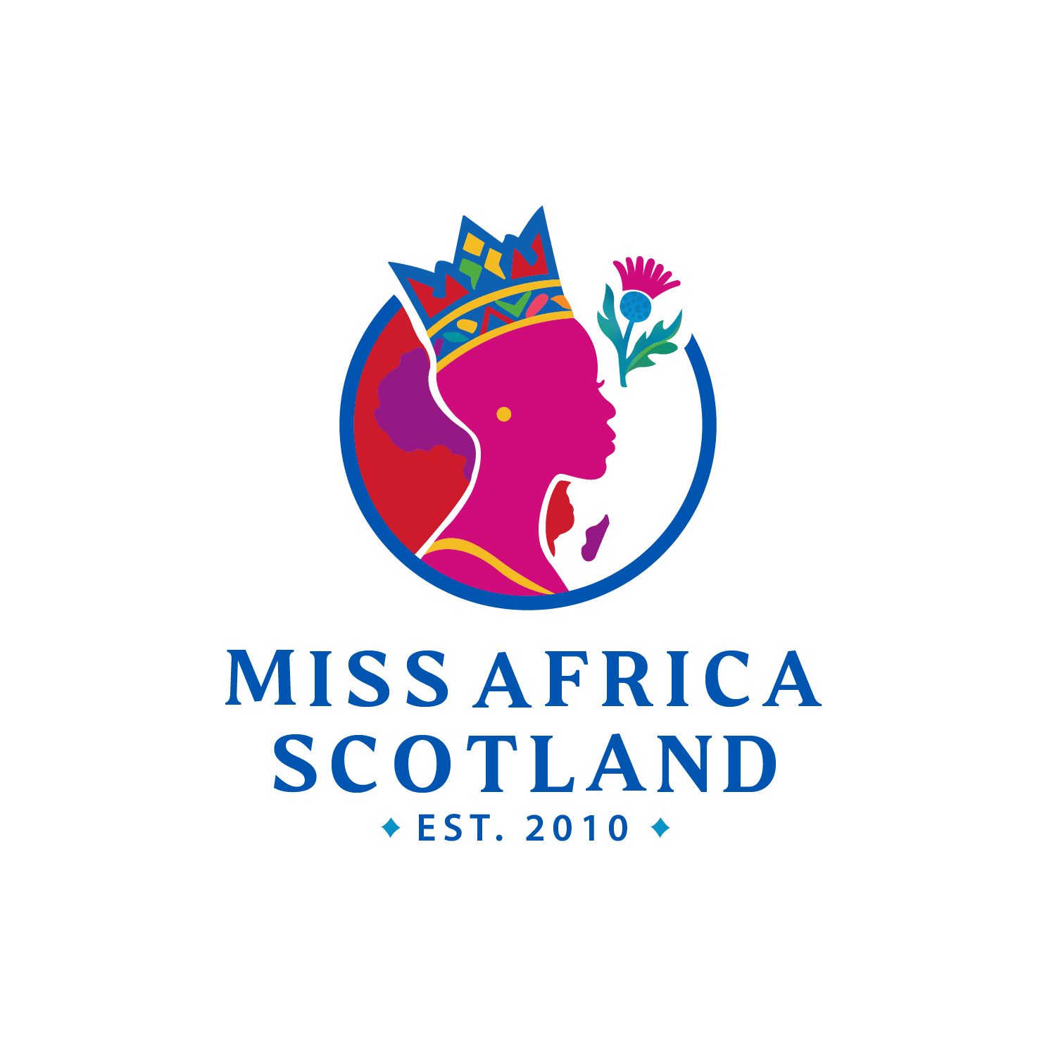

CONTESTANT APPLICATION, CONSENT & RELEASE AGREEMENT
This Contestant Application, Consent & Release Agreement (“Agreement”) is entered into between:
Miss Africa Scotland, an organised cultural leadership and development program (“the Program”), operated and managed by Georgia Tah and Kẹ́mi Kọ́mọláfẹ́ (together, “the Organisers”),
and
The undersigned applicant (“the Participant”).

1. ELIGIBILITY & APPLICATION DECLARATION
1.1 The Participant confirms that they are between sixteen (16) and thirty-two (32) years of age at the time of application.
1.2 The Participant confirms that all information submitted as part of the application process is true, accurate, complete, and not misleading.
1.3 The Organisers reserve the sole and absolute discretion to accept or reject any application without obligation to provide reasons.

2. TERM OF AGREEMENT
2.1 This Agreement shall commence on the date of signing and shall remain in force:
- For all Participants: for the full duration of their involvement in the Program, including preparation, appearances, rehearsals, events, and post-event obligations.
- For the selected titleholder (“Miss Africa Scotland”): for the full official titleholding term, and any extended obligations reasonably connected to the role.

3. EXCLUSIVITY, LOYALTY & NON-CONFLICT
3.1 The Participant agrees that, during their participation in the Program, they shall not engage in, associate with, promote, compete in, or collaborate with any competing or conflicting:
- cultural programs,
- leadership titles,
- representation initiatives,
- modelling competitions,
- brand ambassadorships,
- or similarly positioned events or organisations,
without the prior written consent of the Organisers.
3.2 The Participant acknowledges that loyalty to Miss Africa Scotland is fundamental to the integrity, reputation, and mission of the Program.
3.3 Any breach of exclusivity or loyalty obligations shall be considered a material breach of this Agreement and may result in immediate disqualification, termination, or revocation of participation or title, without compensation.

4. CONDUCT, VALUES & REPRESENTATION
4.1 The Participant agrees to conduct themselves at all times in a manner that upholds the dignity, values, cultural integrity, and public reputation of Miss Africa Scotland.
4.2 The Participant shall not engage in conduct (online or offline) that may reasonably be considered:
- defamatory,
- discriminatory,
- abusive,
- unlawful,
- or damaging to the reputation of the Program or the Organisers.
4.3 The Organisers reserve the right to determine, at their sole discretion, whether conduct constitutes a breach of this clause.

5. MEDIA, IMAGE & INTELLECTUAL PROPERTY RELEASE
5.1 The Participant grants Miss Africa Scotland and the Organisers a perpetual, irrevocable, royalty-free, worldwide licence to use their:
- name,
- image,
- likeness,
- voice,
- biography,
- photographs,
- video recordings,
- and all related content,
for promotional, editorial, commercial, archival, and educational purposes, across all media formats, now known or later developed.
5.2 The Participant waives any right to inspect or approve final media content.

6. TITLEHOLDER-SPECIFIC OBLIGATIONS
6.1 The Participant acknowledges that, if selected as Miss Africa Scotland, they shall act as an official representative and ambassador of the Program.
6.2 All activities, appearances, endorsements, partnerships, initiatives, projects, campaigns, and public engagements undertaken in the capacity of Miss Africa Scotland must receive prior approval and ongoing consent from the Organisers, Georgia Tah and Kẹ́mi Kọ́mọláfẹ́.
6.3 The titleholder shall not independently:
- enter into sponsorships,
- accept gifts or benefits,
- represent third-party brands,
- or engage in public initiatives under the Miss Africa Scotland title,
without express written authorisation from the Organisers.

7. HEALTH, SAFETY & ASSUMPTION OF RISK
7.1 The Participant confirms that they are physically and mentally fit to take part in the Program and voluntarily assumes all reasonable risks associated with participation.
7.2 The Participant releases the Organisers from liability for any injury, loss, or damage, except where caused by gross negligence or wilful misconduct.

8. TERMINATION
8.1 The Organisers reserve the right to terminate this Agreement immediately in the event of:
- breach of exclusivity or loyalty,
- misconduct,
- misrepresentation,
- reputational harm,
- or failure to comply with Program requirements.
8.2 Termination may occur without refund, compensation, or further obligation.

9. CONFIDENTIALITY
9.1 The Participant agrees to keep confidential all non-public information relating to the Program, including internal processes, judging, deliberations, contracts, and strategy.

10. MINORS (AGES 16–17)
10.1 Where the Participant is under eighteen (18) years of age, this Agreement must be co-signed by a parent or legal guardian, who:
- gives full consent to participation,
- agrees to all terms herein,
- and releases the Organisers from liability to the fullest extent permitted by law.

